- Course Code-ENCS351
- Course Name–Operating system
- Program Name: B.Tech.CSE-AIML

- Student Name:KESHAV SHARMA
- Roll No.2301730221
- GitHub Repository Link: https://github.com/keshavvtech/Keshav_OPERATING-SYSTEMS-LAB


Problem Title:
Simulation of File Allocation,Memory Management,and Scheduling in Python
Problem Statement:
Operating systems rely on robust memory management techniques, efficient CPU scheduling policies, and optimized file allocation strategies to manage hardware resources effectively. This lab aims to simulate various such components using Python. Students will implement and analyze Priority and Round Robin scheduling, simulate file allocation techniques (Sequential and Indexed), and explore memory management strategies (MFT, MVT, Worst-fit, Best-fit, First-fit). These implementations will reinforce theoretical OS concepts through hands-on coding experience.

Tools/Technology Used:
- Python 3.x
- Built-in Python libraries: os, multiprocessing, time
- Linux OS (optional for simulation)
Learning Objectives:
- Simulate and analyze CPU scheduling algorithms.
- Implement file allocation techniques in Python.
- Demonstrate memory management strategies including MFT and MVT.

Assignment Tasks:

Task1:CPU Scheduling with Gantt Chart

Write a Python program to simulate Priority and Round Robin scheduling algorithms. Compute average waiting and turnaround times.
#Priority Scheduling Simulation

processes=[] n=int(input("Enternumberofprocesses:")) for i in range(n):
bt=int(input(f"EnterBurstTimeforP{i+1}: ")) pr=int(input(f"EnterPriority(lowernumber=higherpriority)forP{i+1}:"))
processes.append((i+1, bt, pr)) processes.sort(key=lambdax:x[2]) wt
= 0 total_wt=0
total_tt= 0 print("\nPriority Scheduling:") print("PID\tBT\tPriority\tWT\tTAT")
for pid, bt, pr in processes:
tat = wt + bt print(f"{pid}\t{bt}\t{pr}\t\t{wt}\t{tat}") total_wt += wt total_tt+=tat wt
+= bt print(f"Average Waiting Time: {total_wt / n}") print(f"AverageTurnaroundTime:{total_tt/n}")

code:
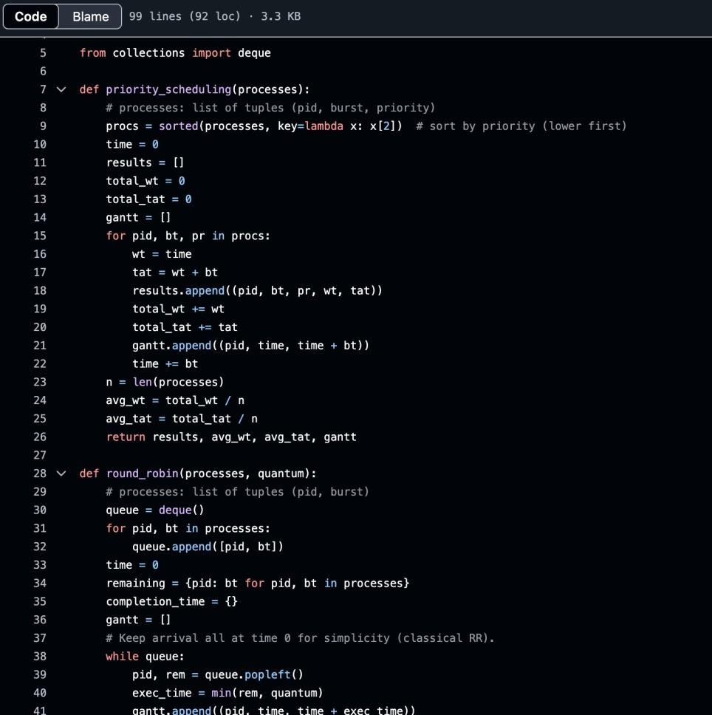

Output:

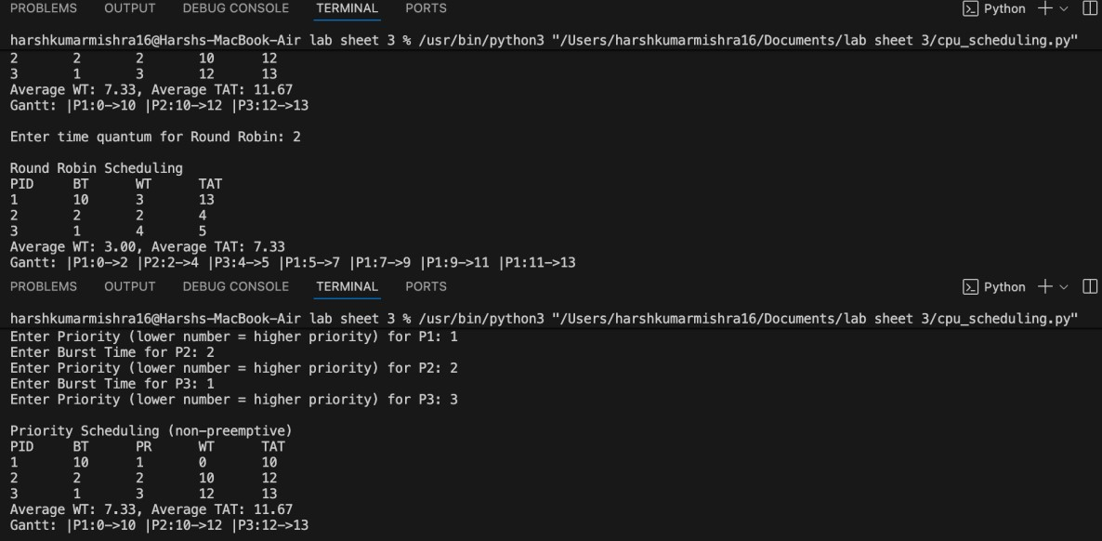

Task2:Sequential File Allocation
Write a Python program to simulate sequential file allocation strategy.
total_blocks = int(input("Enter total number of blocks: ")) block_status = [0] * total_blocks n = int(input("Enter number of files: ")) for i in range(n): start = int(input(f"Enter starting block for file {i+1}: ")) length = int(input(f"Enter length of file {i+1}: ")) allocated = True for j in range(start, start+length): if j >= total_blocks or block_status[j] == 1: allocated = False break if allocated: for j in range(start, start+length): block_status[j] = 1 print(f"File {i+1} allocated from block {start} to {start+length-1}") else: print(f"File {i+1} cannot be allocated.")

code:
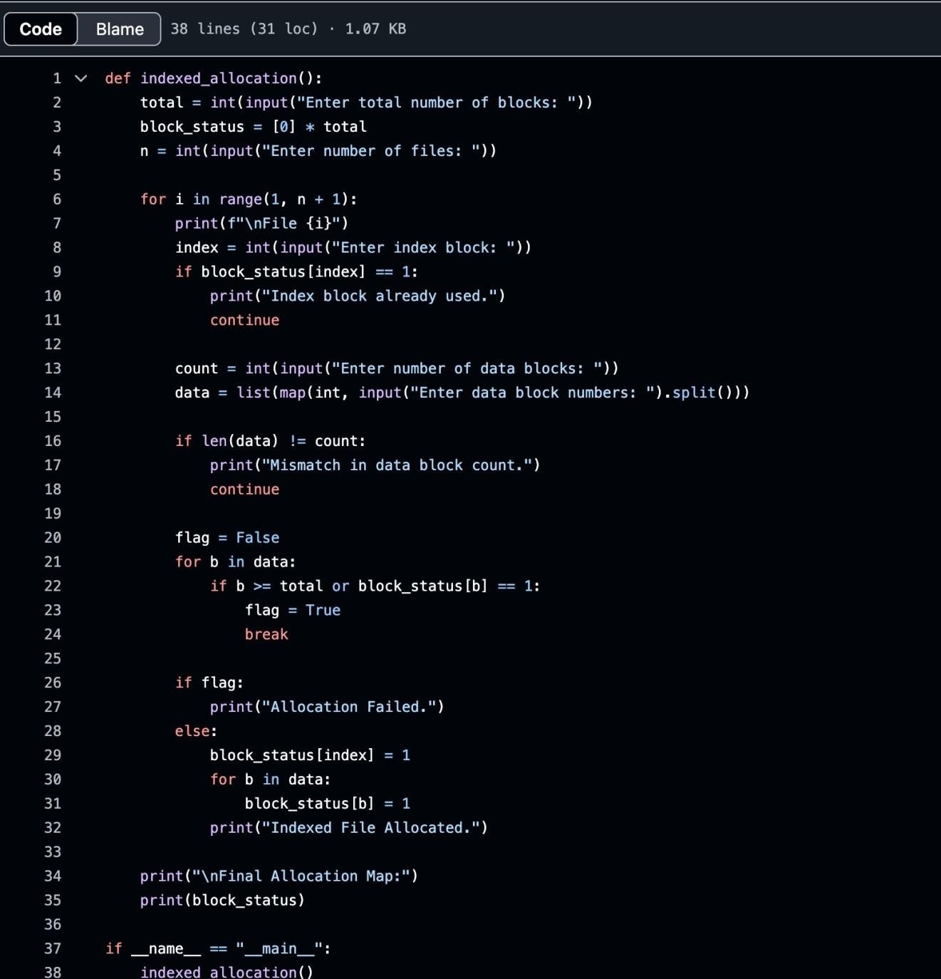

Output:

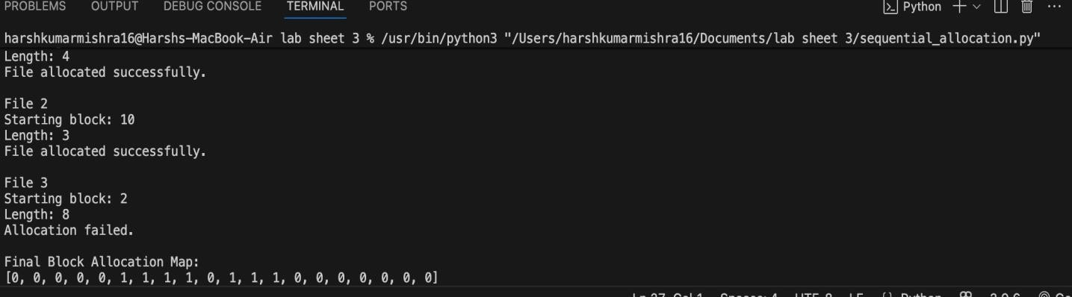

Task 3:Indexed File Allocation

Write a Python program to simulate indexed file allocation strategy. total_blocks=int(input("Enter total number of blocks:")) block_status = [0] * total_blocks n=int(input("Enter number of files:")) for i in range(n):
index=int(input(f"Enter index block for file{i+1}:")) if block_status[index] == 1:
print("Index block already allocated.") continue count=int(input("Enter number of data blocks:")) data_blocks=list(map(int,input("Enter block numbers:").split())) if any(block_status[blk]==1 for blk in data_blocks)or len(data_blocks)!=count:
print("Block(s) already allocated or invalid input.") continue
block_status[index]=1 for blk in data_blocks: block_status[blk]=1
print(f"File{i+1}allocated with index block{index}->{data_blocks}")

code:
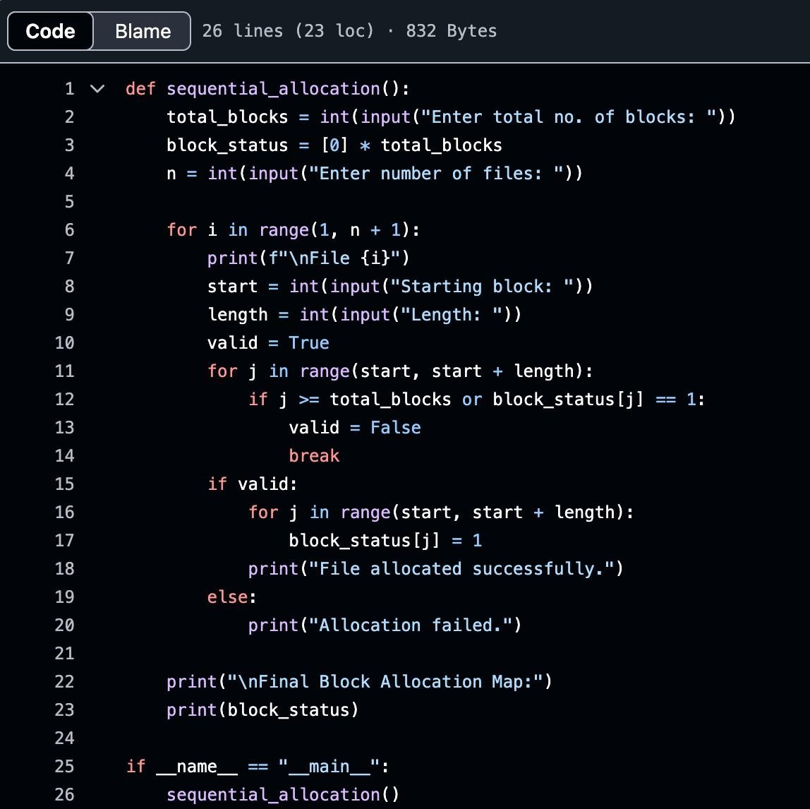

Output:
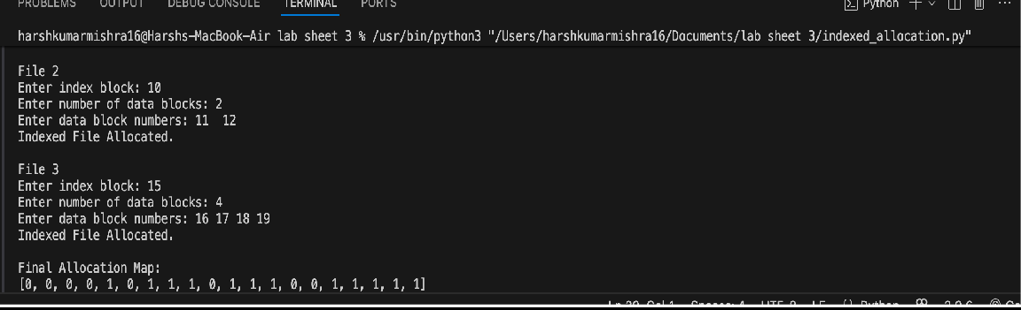

Task4: Contiguous Memory Allocation
Simulate Worst-fit,Best-fit,and First-fit memory allocation strategies.
def allocate_memory(strategy):
partitions=list(map(int,input("Enter partition sizes:").split())) processes = list(map(int, input("Enter process sizes: ").split())) allocation = [-1] * len(processes)

for i,psize in enumerate(processes):
idx = -1
if strategy== "first": for j,part in enumerate(partitions):
if part >= psize:
idx=j break
elif strategy == "best": best_fit= float("inf")
for j, part in enumerate(partitions):
if part>=psize and part<best_fit: best_fit
= part
idx = j elif strategy=="worst":
worst_fit = -1 for j, part in enumerate(partitions):
if part>=psize and part>worst_fit:
worst_fit = part
idx=j if idx != -1:
allocation[i] = idx
partitions[idx]-=psize

for i, a in enumerate(allocation):
if a != -1: print(f"Process{i+1}allocated in Partition{a+1}") else:
print(f"Process{i+1}cannot be allocated")

allocate_memory("first") allocate_memory("best") allocate_memory("worst")

code:
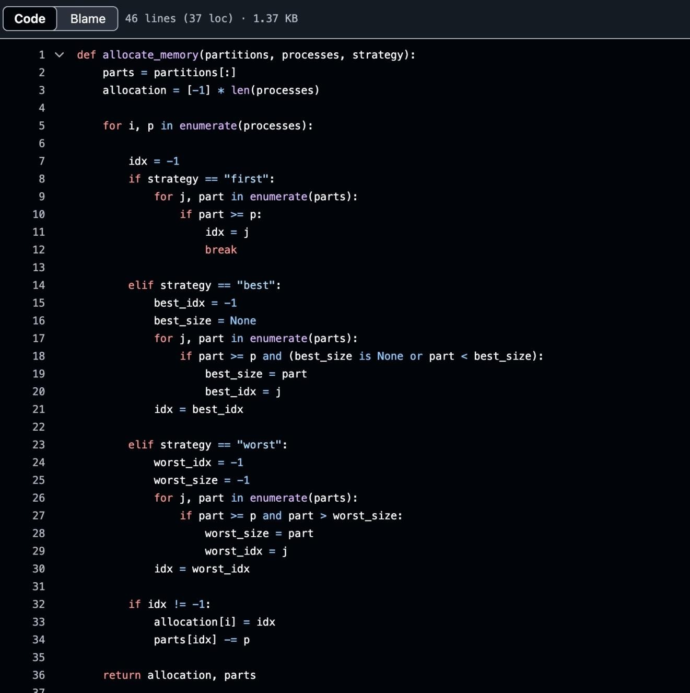

Output:

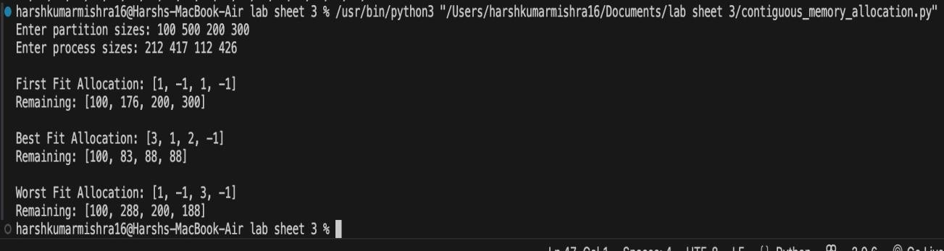

Task5: MFT& MVT Memory Management
Implement MFT(fixed partitions)and MVT(variablepartitions)strategies in Python.
def MFT():
mem_size=int(input("Enter total memory size:")) part_size = int(input("Enter partition size: ")) n=int(input("Enter number of processes:")) partitions = mem_size // part_size print(f"Memory divided into{partitions}partitions") for i in range(n):
psize=int(input(f"Enter size of Process{i+1}:")) if psize <= part_size: print(f"Process{i+1}allocated.") else:
print(f"Process{i+1}too large for fixed partition.")

def MVT():
mem_size=int(input("Enter total memory size:")) n = int(input("Enter number of processes: ")) for i in range(n):
psize=int(input(f"Enter size of Process{i+1}:")) if psize <= mem_size: print(f"Process{i+1}allocated.") mem_size -= psize
else:
print(f"Process{i+1}cannot be allocated.Not enough memory.")
print("MFT Simulation:") MFT() print("\nMVT Simulation:")
MVT()
code:

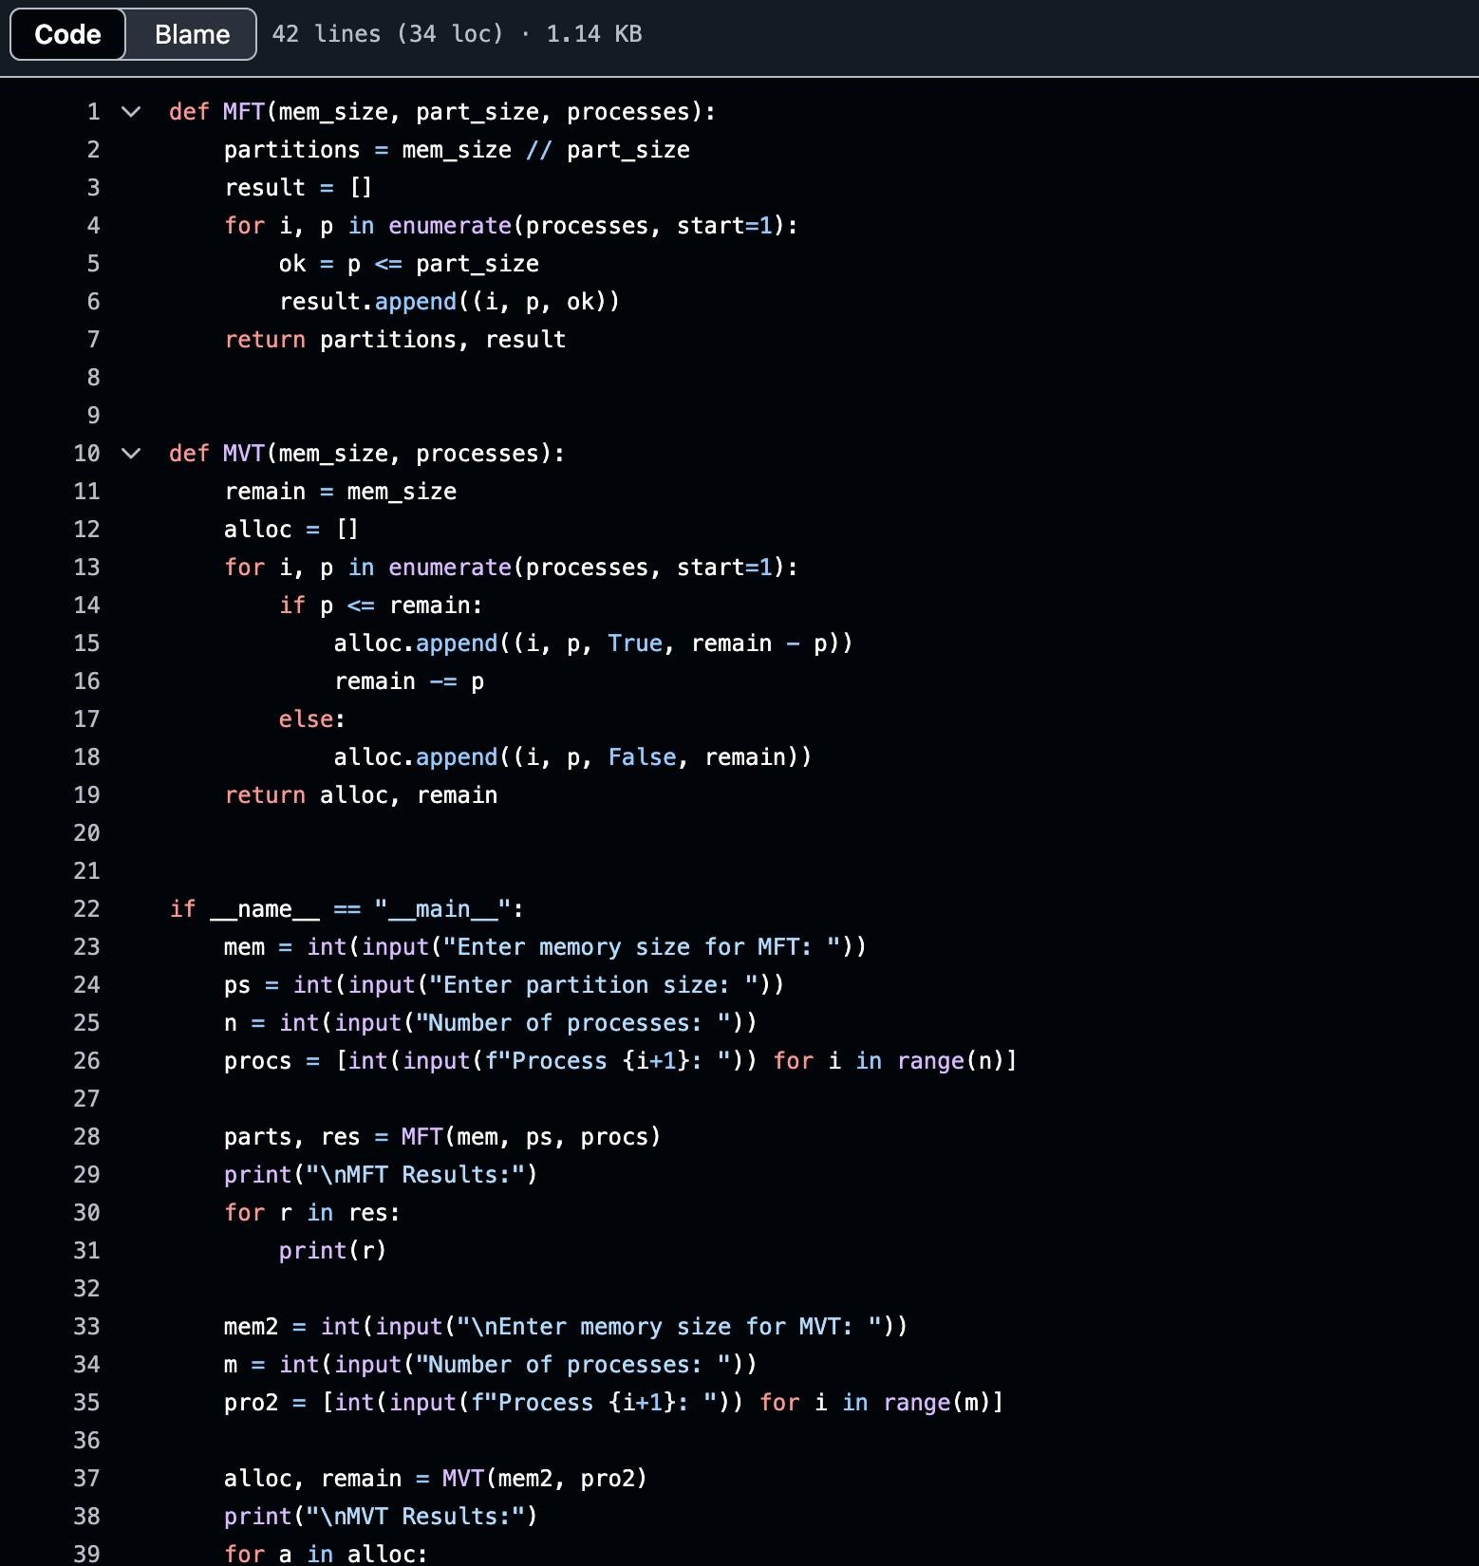
Output:

